

|  |  |  |
| --- | --- | --- |
| AAC BLOCK & PANEL  INDUSTRY STUDY | |  |
|  | | | |
| Written By:  Mohammed Alshammari, Ast. Analyst | Reviewed By:  Mesfer Al-Qahtani | | |

# EXECUTIVE SUMMARY

Purpose of The Study

This industry study is done primarily in response to the management request in order to assess the current and the outlook of the Building Technologies Industry including ACC blocks & Panels industry in the kingdom and update the study as per the policy. The market review objectives are to quantify current and future demand and define the various elements in the AAC Blocks & Panels industry, assessing the market size of each,Mm and determining the trends in the market. This study aims to provide recommendations to SIDF management towards setting future lending policy for this sector from a marketing point of view.

Current SIDF Policy

SIDF policy stated that AAC Blocks & Panels Industry Study that was reviewed by Loan Committee Meeting #1719 Dated 19/06/1437H, with approval given to the following recommendations:

* No application(s) for new or existing projects for the AAC/Foamed Concrete Sectors to be accepted.

Market Situation & Outlook

The market is completely supplied by local manufacturers. The table below shows the supply demand situation regarding AAC blocks & panels in the kingdom during the last three years based on 3 shifts/8 of hours per shift:

It should be noted that the installed capacities can vary depending on some factors including the specifications of panels and blocks and the sizes required by the customer, where the unused panel capacity is being repurposed for block production. As it can be seen from the above table, the local demand for AAC blocks product has been on a downward trend, it dramatically fell by 27% in 2018G to 373,432 m3, due to the slowdown in the construction sector. In 2019, there were a dramatical shift towards AAC panels. The sales for AAC panels increased by 293% due to the higher profit margin for panels and cheaper than AAC block as a ratio to the size and contributed mainly by the housing projects. Exports represent about 34% and 4% of AAC Blocks and panels respectively during 2019 and it is mainly to GCC countries.

Supply/Demand Balance

Based on the analysis of the future supply/demand situation of AAC blocks & Panels, it can be noticed that there will be a surplus in the local market. The market shows surplus this year 2020 until 2024 as a result of the entrance of some producers in 2020 and 2021 namely Asas Al-Bena Factory – Appl: 20025 and Al-Saedan Building Technology Factory – Appl: 20006.

Based on the analysis of the future supply/demand situation of AAC blocks & Panels, it can be noticed that there will be a surplus in the local market as shown in the above figures. The market shows surplus this year 2020 until 2024 as a result of the entrance of some producers in 2020 and 2021 including Asas Al-Bena Factory and Al-Saedan Building Technology Factory.

Market Price

The prices of AAC blocks depend on some factors including the project location which may result in increasing or reducing the prices. It also related to the molds design and whether they require a sophisticated shop drawing design or not. The fluctuating prices of some raw materials such as cement, steel, and alumni powder can also contribute to the changes in the prices of AAC products. AAC Blocks and Panels are usually sold ex-factory, on a price/M3 basis, to be collected by the customer on cash-on-delivery terms. The historical and present selling prices of AAC products (per cubic meter) in the Kingdom for the local producers are as following:

The figure above shows that the average market price has been stable since 2017 for AAC blocks. For ACC panels, in 2020 the prices went up by 2%.

Market Competition

There are four operational local producers of AAC blocks namely Siporex, Saudi AAC Blocks Factory, ACICO, and ESPAC. SIBCO has closed their factories on 2018. There are three operational local producers of AAC panels namely Siporex, ESPAC and ACICO who recently entered this market on 2019.

Opportunities

* The Ministry of Housing future projects with 1,200,00 houses by 2030.

Threats

* Oversupply situation in the market.
* Low awareness of AAC blocks in the Kingdom.
* Two new plants are expected to come on stream during 2020-2021.
* Fluctuating in prices of raw materials (cements and aluminum paste).

Conclusion & Recommendation

ACC blocks & panels market in Saudi Arabia has been surplus since 2017 and expected to continue until 2024. Moreover, most of gulf countries has surplus as well in the AAC market. MCD believes that the current producers and the future expansions will result of a surplus in the ACC blocks & panels market in Saudi Arabia. MCD recommends that the sector has to remain closed.

1. No applications for new start-up ventures are to be accepted, only modernization or relocation with minimum increase in the capacity.

2. The industry is to be reviewed again in 2 years.

Table of Contents

EXECUTIVE SUMMARY…………………………………………………………………………….……. 1

1.OVERVIEW…………………………………………………………………………………………….…… 6

1.1 Introduction………………………………………………………………………………………… 6

1.2 Study Methodology…………………………………………………………………………….. 6

1.3 Current SIDF Lending Policy…………………………………………………………………. 6

2. PRODUCT & APPLICATIONS……………………………………………………………….………. 7

2.1 Product……………………………………………………………………………………………….. 7

2.2 Raw Material……………………………………………………………………………………….. 7

2.3 AAC Block & Panel Properties………………………………………………………………. 8

2.4 Comparison of Different Structural Construction Materials……………….…. 8

2.5 Alternative Product Products………………………………………………………………. 9

2.6 Advantages………………………………………………………………………………………….. 9

2.7 Disadvantages……………………………………………………………………………………… 9

3.Manufacturing Process………………………………………………………………………….…… 10

4. MARKET CHARACTERISTIC…………………………………………………………………….….. 12

4.1 Market Growth……………………………………………………………………………………. Error! Bookmark not defined.

4.2 KSA Supply/Demand……………………………………………………………………………. 12

4.3 New Comers & Additional Capacities…………………………………………………… 13

4.4 KSA Future Demand…………………………………………………………………………….. 13

4.5 Supply / Demand Balance……………………………………………………………………. 15

4.6 Price………………………………………………………………..………………………………….. 17

4.7 Competition………………………………………………………………………………………… 18

5. Opportunities & Threats…………………………………………………………………….……… 19

6. Conclusion…………………………………………………………………………………………….….. 19

7. Recommendation…………………………………………………………………………………..…. 19

Appendixs……………………………………………………………………………………………………. 20

# 1.OVERVIEW

## 1.1 Introduction

This market review is done primarily in response to the management request in order to assess the current and the outlook of the Building Technologies Industry including ACC blocks & panels industry in the kingdom and update the study as per the policy. The market review objectives are to quantify current and future demand and define the various elements in the AAC blocks & panels industry, assessing the market size of each, and determining the trends in the market. This study aims to provide recommendations to SIDF management towards setting future lending policy for this sector from a marketing point of view.

## 1.2 Study Methodology

This study is based on the available information to the Marketing Consultancy Division from the previous loan reviews of the AAC blocks & panels manufactures, discussions with selected manufactures of AAC block & panel in Saudi Arabia, as well as the numbers shared publicly by the Ministry of Housing for the Building Technology Stimulus Initiative (BTSI).

## 1.3 Current SIDF Lending Policy

SIDF policy stated that AAC Blocks & Panels Industry Study that was reviewed by Loan Committee Meeting #1719 Dated 19/06/1437H, with approval given to the following recommendations:

* No application(s) for new or existing projects for the AAC/Foamed Concrete Sectors to be accepted.
* The industry is to be reviewed again in 1441H.

# 2. PRODUCT & APPLICATIONS

## 2.1 Product

Autoclaved Aerated Concrete (AAC) is a structural insulating material, invented in the mid-1920s by the Swedish architect and inventor Johan Axel Eriksson. AAC products come in the form of steel reinforced panels and lintels, and as unreinforced building blocks. It is a type of foamed concrete, often called “aircrete” in the West. The raw materials are mixed with water which causes the aluminum powder to release hydrogen, expanding the mixture which is then cut into blocks or panels before autoclaving. The production of panels involves an additional line where steel reinforcement is incorporated into the panel prior to autoclaving. This diverts capacity from block making.

AAC block: serve as load or non-load bearing internal or external walls. AAC blocks are lightweight and feature excellent thermal and noise insulation characteristics. AAC blocks come in a wide range of sizes, the most popular of which is 60x20x20cm3, with a density of 550 kg/m3. They are laid on a thin bed of mortar, typically 2mm-3mm thick.

AAC Panels: generally, 600mm wide and up to 6 meters long and are reinforced. Typically, when installed lengthwise, they are used as cladding to steel or concrete framed structures, such as warehouses, commercial and industrial buildings. AAC panels can be produced in a broad range of sizes, and with spans up to 6 meters, while the blocks are cut to any desired size.

## 2.2 Raw Material

The primary raw materials are silica sand (69%), cement (19%), limestone (8%), gypsum (3%) and aluminum powder (1%). The raw materials are readily available in the Kingdom except the aluminum powder imported from India and France. Below is the description of each substance used in the AAC block manufacturing process.

* Sand: Fine aggregate are basically sand consists of crushed stone with maximum particles passing through a 4.75mm sieve. As per codal provision IS 383:1970, the silica content shall not be less than 80%.
* Cement: Cement is a binder, a substance used in construction industry that sets and hardens and can bind other materials together.
* Limestone: Limestone is made up of calcite aragonite referring figure 6 Limestone is obtained either by crushing to fine powder at AAC factory or by directly purchasing it in powder form from a merchant.
* Gypsum: Gypsum is easily available in the market and is used in powder form.
* Aluminum Powder: Aluminum is an expansion agent. When the raw material reacts with aluminum powder, air bubble introduced due to reaction between calcium hydroxide, aluminum and water and hydrogen gas is released.

## 2.3 AAC Block & Panel Properties

AAC blocks & panels has been successful used for long time and a significant body of knowledge and information has been accumulated about its properties. Below table shows the main properties of AAC block and panel.

Table : AAC block & panel properties.

|  |  |  |  |  |
| --- | --- | --- | --- | --- |
| Dry Density (kg/m3) | Compressive Strength (MPa) | Flexural Strength (MPa) | E- value (GPa) | K value (W/mK) |
| 450 | 3.2 | 0.65 | 1.6 | 0.12 |
| 525 | 4.0 | 0.75 | 2.0 | 0.14 |
| 600 | 4.5 | 0.85 | 2.4 | 0.16 |
| 675 | 6.3 | 1.00 | 2.5 | 0.18 |
| 750 | 7.5 | 1.20 | 2.7 | 0.20 |

## 2.4 Comparison of Different Structural Construction Materials

The following table compares the main properties of AAC blocks with other structural construction materials used in the Kingdom from a thermal insulation and mechanical strength perspective:

Table : Comparison of Different Structural Construction Material.



Note that lower the K-Value, the thermal conductivity, the better. This table highlights the benefits of AAC blocks vs other structural solutions not just from a thermal insulation standpoint, but also from the perspective of low weight (density).

## 2.5 Alternative Product Products

The construction industry is characterized by several block substitutes. The most closely related substitute product for AAC blocks are thermo blocks. The other close substitutes are traditional concrete blocks and red bricks which have more weight but cheaper in their cost were AAC blocks clearly have an advantage over other blocks in respect to thermal efficiency and the weight, which means savings on account of construction cost and electricity bill. However due little customer awareness of AAC blocks in the market and higher selling price, customers prefer other substitutes over AAC blocks. With extra marketing efforts, this product is acknowledged to pose a real threat to the position of substitute’s blocks, where it has major advantages over traditional blocks such as its light weight were AAC blocks is a lightweight product compared to other solid building materials. The low weight has advantage for transportation and working for structural design. However, AAC blocks have the disadvantage of having higher prices compared to other alternative materials and a greater inflexibility to modify the building after it is completed.

## 2.6 Advantages

The popularity of AAC blocks is due to the immense advantages it offers such as:

* Multi-functional; can combine load bearing action with insulation function.
* Dimensional stability and excellent fire resistance.
* Can be cut with saw like wood, light weight, hence reduces structural load.
* Resources efficiency gives it lower environmental impact in all phases of its life cycle, form the processing of raw materials to the disposal of waste.
* For structural use, grouted, reinforced cells and beams are placed within the wall section. (Concave depressions along vertical edges can create a cylindrical core between 2 adjacent panels.)
* Non-toxic: There are no toxic gases or other toxic substances in autoclaved aerated concrete.

## 2.7 Disadvantages

Although the advantages of AAC blocks far outweigh its disadvantages, it does have following notable disadvantages:

* Installation during rainy weather: aircrete is known to crack after installation, which can be avoided by reducing the strength of the mortar and ensuring the blocks are dry during and after installation.
* Brittle nature: they need to be handled more carefully than clay bricks to avoid breakage.

# 3.Manufacturing Process

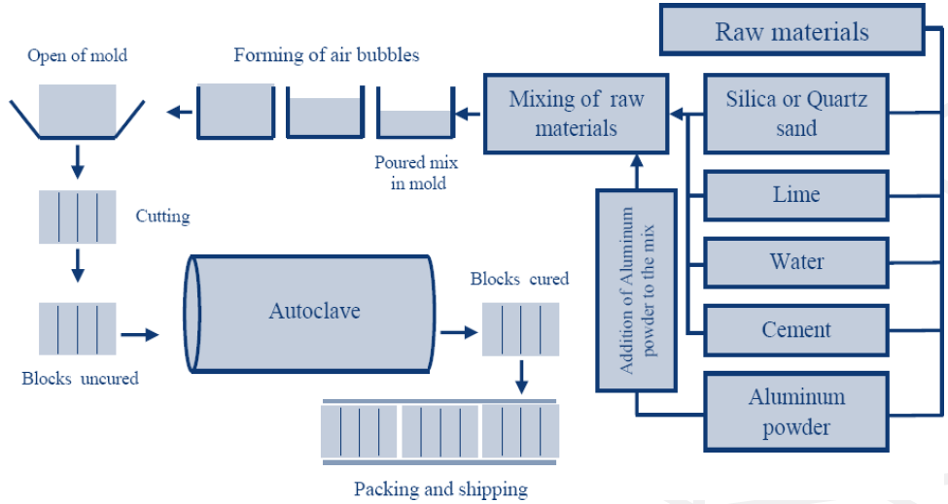

Figure : Manufacturing Process of AAC Block & Panel.

Step 1 – Raw Material Preparation:

AAC blocks manufacturing process starts with raw material preparation.

Step 2 – Dosing and Mixing:

After raw material preparation, next step of AAC blocks manufacturing process is dosing and mixing. Process of dosing and mixing means the quality of final products. Maintaining ratio of all ingredients as explained in the raw material section. The cycle of mixing and pouring is 5.5 minutes. A dosing and mixing unit is used to form the correct mix to produce AAC blocks. Fly ash is pumped into a container. Once the desired weight is poured in, pumping is stopped. Similarly lime powder, cement and gypsum are poured into individual containers using conveyors. Once required amount of each ingredient is filled into their individual containers control system releases all ingredients into mixing drum. A smaller bowl type structure used for feeding Aluminum powder is also attached as a part of mixing unit. Once the mixture has been churned for set time, it is ready to be poured into molds using dosing unit. Dosing unit releases this mixture as per set quantities into molds. Dosing and mixing process is carried out continuously because if there is a gap between charging and discharging of ingredients, residual mixture might start hardening and choke up the entire unit. For AAC blocks manufacturing, entire dosing and mixing operation is completely automated and requires minimum human intervention.

Step 3 – Casting, Rising and Curing:

Once mix of raw materials is ready, it poured is in molds. Molds can be of various sizes depending upon installed capacity like 4.2m x 1.2m x 0.65m in size. Before casting, molds are coated with a thin layer of oil in order to ensure that green-cake does not stick to molds. While slurry is mixed and poured into greased molds, Aluminum reacts with Calcium Hydroxide and water and releases hydrogen gas. This leads to formation of tiny cells causing slurry mix to expand. Such expansion may be thrice its original volume. Bubble size is about 2- 5mm. Thus, this is the reason behind light weight and insulating properties of AAC block. When rising process is over, green-cake is allowed to settle &cure. Usually rising and pre-curing process takes around 60-240 minutes. Rising is dependent on raw material mix and weather conditions. Due to this, pre-curing is also referred as ‘heating room pre-curing’. At end of precuring process, green-cake is hard enough to be wire cut as per requirements. Autoclave Aerated concrete is cured in an autoclave – a large pressure vessel. Autoclave is normally a steel tube of 3m diameter and 45 meters long. Steam is fed into the autoclaved at high pressure, typically reaching a pressure of 800kPa to 1200 KPa and a temperature of 180°C.

Step 4 – Demoulding and Cutting:

Once green cake has achieved cutting strength, it is ready to be demoulded and cut as per requirements. Once a mold is out of pre-curing room, it is lifted by a crane for demoulding operation. While all previous processes like raw material preparation, dosing & mixing and casting are pretty much same across all technologies, demoulding and cutting process vary vastly depending on technology provider. Differences in demoulding and cutting process are also evident from different types of molds required by different technology provider. Primarily cutting process may be classified as flat-cake and tilt-cake based on how green cake is demoulded and sent to cutting line.

# 4. MARKET CHARACTERISTIC

## 4.1 Historical Supply/Demand

The market is completely supplied by local manufacturers as there are three manufacturers of AAC panels and four manufacturers of AAC blocks in the Kingdom operating based on 3 shifts/8 of hours per shift. The following table shows the supply and demand during the last three years:

Figure : Historical Demand - AAC Block (M3).

Figure : Historical Demand - AAC Panel (M3).

It should be noted that the installed capacities can vary depending on some factors including the specifications of panels and blocks and the sizes required by the customer, where the unused panel capacity is being repurposed for block production. As it can be seen from the above table, the local demand for AAC blocks product has been on a downward trend, it dramatically fell by 27% in 2018G to 373,432 m3, due to the slowdown in the construction sector. In 2019, there were a dramatical shift towards AAC panels. The sales for AAC panels increased by 293% due to the higher profit margin for panels and cheaper than AAC block as a ratio to the size and contributed mainly by the housing projects. Exports represent about 34% and 4% of AAC Blocks and panels respectively during 2019 and it is mainly to GCC countries

## 4.2 New Comers & Additional Capacities

There are two new comers in this sector will start production by 2020G (i.e., Al-Saedan Building technology in Al-Kharj and Asas Al-Bena Company for Industry, Sudiar).

Table : New comers in the AAC market.

|  |  |  |  |
| --- | --- | --- | --- |
| Factory | Product Type | Installed Capacity (M3) | Year |
| Al-Saedan Building Technology, Al-Kharj | Blocks | 27,541 | 2020 |
| Panels | 130,965 |
| Asas Al-Bena Company For Industry, Sudair | Blocks | 150,000 | 2021 |
| Panels | 210,000 |
| Siporex | Blocks | 150,384 | 2021 |
| Panels | 182,043 |
| Total | | 850,933 | - | |

## 4.3 KSA Future Demand

The future demand growth for owing homes will be dependent upon the growth of the Real-Estate sector which in turn will be dependent upon the population growth, the growth in the governmental projects such as the Ministry of Housing and commercial constructions, and GDP growth.

Population Growth: The Saudi population will continue to grow with the influx of expatriates from all over the world. In 2020, the population of Saudi Arabia stands at 34.81 million according to the data provided by the World Bank. That translates to a growth rate of 1.97% from 2019 when the population of Saudi Arabia was estimated to be 34.14 million. One fourth Saudi population (8,386,306) is between the age 30 to 50. Assuming only 15% will start constructing their own houses, this represents 1,257,946 new houses.

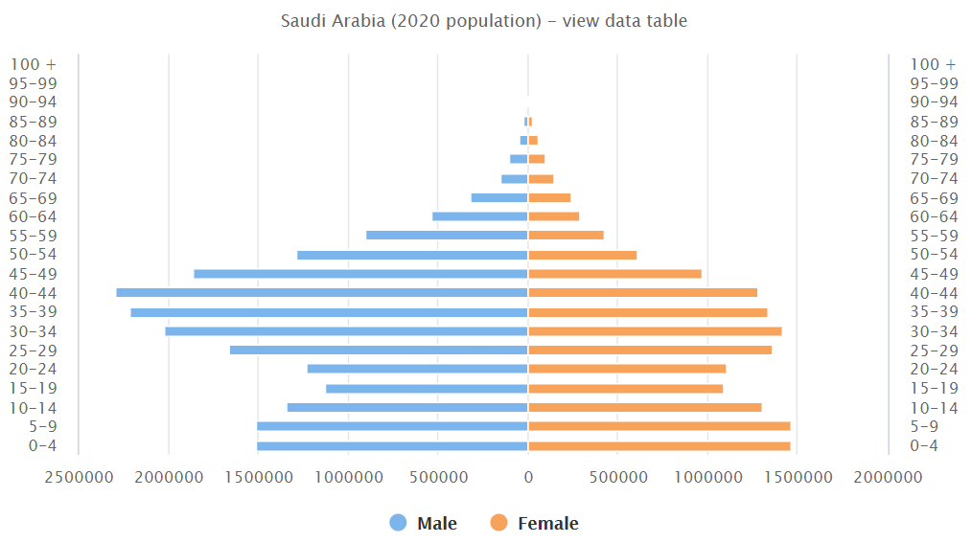

Figure : Saudi population growth.

Governmental Projects: The Ministry of Housing announce a new program called Building Technology Stimulus Initiative (BTSI). This program aspires to bridge the housing gap with 680k affordable and developmental housing units allocated by 2023. The program of Building Technology Fund have a specific focus of financing the expansion and the establishment of industrialized technology factories with the dual mission of meeting capacity objectives while stimulating the housing sector and local supply chain.

A major opportunity arises in the provision of more affordable housing for a rapidly growing and youthful population. Saudi Arabia’s fast growing and young population, along with a decline in the average household size, all drive demand for additional residential dwellings in all major urban areas. The major customers of AAC products according to the local producers are contractors and retailers. AAC blocks are mostly used by the retailers and individual homeowners while the ACC panels are popular with the contractors and some government and private organizations such as Saudi Electricity Company, the Royal Commission for Jubail and Yanbu , and Aramco. MCD has taken into account the Ministry of Housing since it holds a great number of projects which can be potential demand of AAC products. Therefore, MCD estimated the future demand during the year of 2020 to reach 0.5% , from 2021 till 2024 to be 2%. The following table shows future demand of AAC products:

Figure : AAC future demand.

## 4.4 Supply / Demand Balance

Accordingly, the following table show the future supply and demand balance for the AAC blocks and panels during the following years:

Figure : Supply/Demand Balance AAC Blocks.

Figure : Supply/Demand Balance AAC Panel.

Based on the analysis of the future supply/demand situation of AAC blocks & Panels, it can be noticed that there will be a surplus in the local market as shown above in figure 12 & 13. The market shows surplus this year 2020 until 2024 as a result of the entrance of some producers in 2020 and 2021 including Asas Al-Bena Factory and Al-Saedan Building Technology Factory.

## 4.5 Price

The prices of AAC blocks depend on some factors including the project location which may result in increasing or reducing the prices. It also related to the molds design and whether they require a sophisticated shop drawing design or not. The fluctuating prices of some raw materials such as cement, steel, and alumni powder can also contribute to the changes in the prices of AAC products. AAC Blocks and Panels are usually sold ex-factory, on a price/M3 basis, to be collected by the customer on cash-on-delivery terms. The historical and present selling prices of AAC products (per cubic meter) in the Kingdom for the local producers are as following:

Figure : AAC market prices.

All the above selling prices are ex-factory and the freight to the destination is borne by the customers. It shows that the average market price has been stable since 2017 for AAC blocks. For ACC panels, in 2020 the prices went up by 2%.

AAC Block: There are four operational local producers of AAC blocks namely Siporex, Saudi AAC Blocks Factory, ACICO, and ESPAC. In terms of AAC blocks, SIPOREX has the largest market share with 50% of the local market. SIBCO has closed their factories on 2018. ESPAC has 23% of the local market while ACICO has 21% of the local market. The existing competitors compete by having a variety of sizes, speed of delivery, and good sources of materials. Most contractors agreed that competition is intense and revolved around prices. In addition, AAC blocks will face competition from the producers of other alternative blocks. Four of the producers have a strong joint venture with a partner who has an existing AAC block manufacturing in other countries for a long time. These competitors have developed good relations with major construction companies and Government bodies.

## 4.6 Competition

AAC Panel: There are three operational local producers of AAC panels namely Siporex, ESPAC and ACICO who recently entered this market on 2019. In terms of AAC panels, Siporex has the largest market share with 46% of the local market. ESPAC has 39% of the local market. SIBCO has closed their factories on 2018.

Figure : Market share of AAC block and panel.

## 5. Opportunities & Threats:

Opportunities:

* The Ministry of Housing future projects with 1,200,00 houses by 2030.

Threats:

* Oversupply situation in the market.
* Low awareness of AAC blocks in the Kingdom.
* The selling prices of the AAC blocks compared with the substitutes are higher.
* Two new plants are expected to come on stream during 2020-2021.
* Fluctuating in prices of raw materials (cements and aluminum paste).

## 6. Conclusion

ACC blocks & panels market in Saudi Arabia has been surplus since 2017 and expected to continue until 2024. Moreover, most of gulf countries has surplus as well in the AAC market.

## 7. Recommendation

MCD believes that the current producers and the future expansions will result of a surplus in the ACC blocks & panels market in Saudi Arabia. MCD recommends that the sector has to remain closed.

1. No applications for new start-up ventures are to be accepted, only modernization or relocation with minimum increase in the capacity.

2. The industry is to be reviewed again in 4 years.

## APPENDIXS

Historical Supply/Demand

|  |  |  |  |  |  |  |  |  |  |
| --- | --- | --- | --- | --- | --- | --- | --- | --- | --- |
| Factory | Product Type | | Installed Capacity (M3) | Sales (M3) | | | | | |
| 2017 | | 2018 | | 2019 | |
| Local | Export | Local | Export | Local | Export |
| Siporex, Riyadh | Blocks | | 158,000 | 140,408 | 7,390 | 104,210 | 4,618 | 127,690 | 5,310 |
| Panels | | 120,000 | 32,164 | 1,693 | 23,794 | 931 | 58,917 | 2,284 |
| ACICO, Jubail | Blocks | | 170,000 | 55,000 | 55,000 | 49,500 | 49,500 | 54,450 | 54,450 |
| Panels | | 150,000 | - | - | - | - | 20,000 | 995 |
| ESPAC, Dammam | Blocks | | 150,000 | 73,061 | 84,721 | 65,755 | 76,249 | 59,179 | 68,624 |
| Panels | | 150,000 | 5,463 | 5,169 | 4,917 | 4,652 | 50,000 | 2,500 |
| SIBCO, Jeddah & Riyadh | Blocks | | 300,000 | 64,350 | 4,500 | - | - | - | - |
| Panels | | - | - | - | - | - | - | - |
| Saudi AAC Blocks Factory, Jubail | Blocks | | 80,000 | 24,500 | 5,000 | 19,600 | 4,000 | 15,680 | 3,200 |
| Panels | | - | - | - | - | - | - | - |
| Sub Total | Blocks | | 858,000 | 357,319 | 156,611 | 239,065 | 134,367 | 256,999 | 131,584 |
| 513,930 | | 373,432 | | 388,583 | |
| Panels | | 420,000 | 37,627 | 6,862 | 28,711 | 5,583 | 128,917 | 5,779 |
| 44,489 | | 34,294 | | 134,696 | |
| Total | | | 1,278,000 | 558,419 | | 407,726 | | 523,279 | |
| Growth Rate | | | | - | | -27% | | 28% | |
| Utilization rate | | | | 44% | | 32% | | 41% | |
| Import | | | | 0 | | 0 | | 0 | |
| Demand | | Blocks | | 357,319 | | 239,065 | | 256,999 | |
| Panels | | 37,627 | | 28,711 | | 128,917 | |
| Growth Rate for Block | | | | - | | -33% | | 8% | |
| Growth Rate for Panel | | | | - | | -24% | | 350% | |

KSA Future Demand

|  |  |  |  |  |  |  |
| --- | --- | --- | --- | --- | --- | --- |
| Future Demand | Product | 2020 | 2021 | 2022 | 2023 | 2024 |
| Blocks | 258,284 | 263,450 | 268,719 | 274,093 | 279,575 |
| Panels | 129,562 | 132,153 | 134,796 | 137,492 | 140,242 |
| Growth | | 0.5% | 2.0% | 2.0% | 2.0% | 2.0% |

Future Supply/Demand Balance

|  |  |  |  |  |  |
| --- | --- | --- | --- | --- | --- |
| AAC Blocks | | | | | |
| Supply/Demand Balance (M3) | 2020 | 2021 | 2022 | 2023 | 2024 |
| Supply | 585,541 | 727,541 | 727,541 | 727,541 | 727,541 |
| Demand | 258,284 | 263,450 | 268,719 | 274,093 | 279,575 |
| Surplus/Deficit | 327,257 | 464,091 | 458,822 | 453,448 | 447,966 |
| Export | 132,242 | 133,564 | 136,236 | 138,960 | 141,740 |
| Surplus/Deficit | 195,015 | 330,527 | 322,586 | 314,488 | 306,226 |

|  |  |  |  |  |  |
| --- | --- | --- | --- | --- | --- |
| AAC Panels | | | | | |
| Supply/Demand Balance (M3) | 2020 | 2021 | 2022 | 2023 | 2024 |
| Supply | 550,965 | 822,965 | 822,965 | 822,965 | 822,965 |
| Demand | 129,562 | 132,153 | 134,796 | 137,492 | 140,242 |
| Surplus/Deficit | 421,403 | 690,812 | 688,169 | 685,473 | 682,723 |
| Export | 5,808 | 5,866 | 5,983 | 6,103 | 6,225 |
| Surplus/Deficit | 415,595 | 684,946 | 682,186 | 679,370 | 676,498 |

Market Prices

|  |  |  |
| --- | --- | --- |
| Factory Name | Selling Price (SR/ M3) | |
| Blocks | Panels |
| LCC Siporex | 190 | 625 |
| ESPAC | 190 | 620 |
| ACICO | 170 | 650 |
| SIBCO | 185 | - |
| Saudi AAC Blocks Factory | 170 | - |
| Average Market Price | 181 | 632 |
| Export | 170 | 520 |